

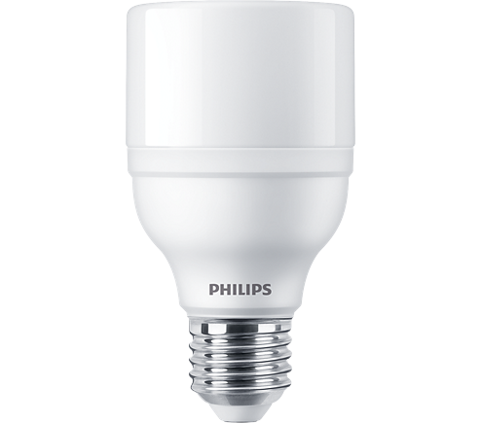

LED BULB

* 17W-115(115W GLS, 27W CFL)W
* E27
* White

**Rs 300.00**